Understanding How to Market Reverse Mortgages
Understanding How to Market Reverse Mortgages

Most people who try to market reverse mortgages fail — not because the product is bad, but because they never understood why it's hard to market in the first place. They jump straight into running ads, burning money, and then conclude that "ads don't work for reverse mortgages."

This lesson is the antidote to that.

Before you spend a single dollar on advertising, you need to understand the philosophy behind marketing this product. You need to understand the unique bottleneck that holds this industry back, who your ideal customer really is, what journey they go on before they become a client, and why certain marketing channels work better than others.

Before we dive in, here's your roadmap for this lesson:

- The Bottleneck — The real reason this industry isn't bigger, and how to overcome it
- Your Ideal Customer (ICP) — Who you're talking to and why it changes everything
- Where to Market — The main channels and why Facebook Ads is the engine of growth

Get this foundation right, and everything else in this bootcamp will click into place.

Part 1: The Bottleneck — A Crisis of Reputation ⛔️

The Core Problem
The single greatest bottleneck in the reverse mortgage industry is not a sales problem. It is a marketing problem, rooted in a deep and persistent crisis of reputation.

The very name of the product — "reverse mortgage" — is a conversion killer. Decades of negative media coverage, outdated product versions, and cultural stigma have turned the term into a red flag. When a prospect hears "reverse mortgage" before they have any context or trust, their brain immediately activates a set of pre-programmed objections. The door closes before you've had a chance to open it.

This is why most reverse mortgage advertising fails. It leads with the product name instead of the outcome.

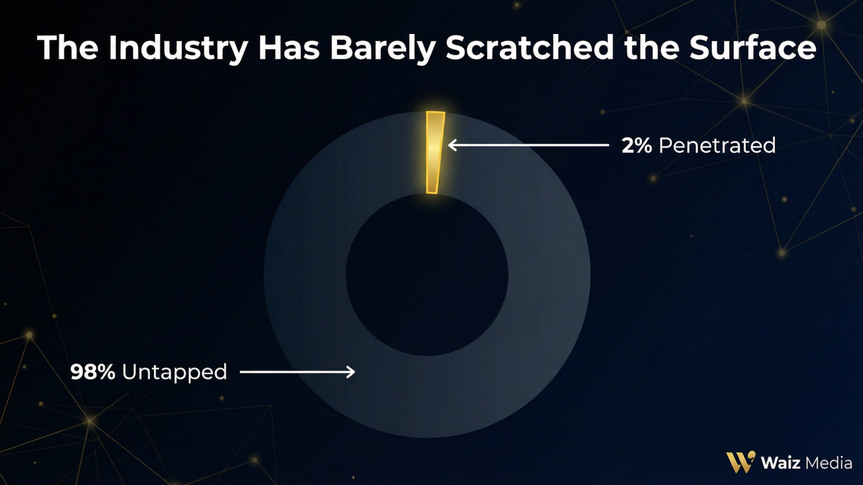

The Lemonade Stand Analogy 🍋
Imagine you set up a lemonade stand with the world's best secret recipe. But instead of a sign that says "Ice-Cold Lemonade," you put up a sign that reads: "SHAKKA — $1."

Cars drive by. Nobody stops. Why? Because nobody knows what "Shakka" is. It's an unknown, untrusted brand.

Now you change the sign to: "ICE-COLD LEMONADE — $1."

Same product. Same kid. Same price. But now, cars stop. The offer is clear, the benefit is immediate, and the brand is understood.

Most reverse mortgage advertising is trying to sell "Shakka." An ad that says "Apply for a Reverse Mortgage" is functionally identical to a sign that says "Apply for a Flibber-Jibbet." It creates confusion and skepticism, not curiosity.

The Principle: Our job is to find people who want what a reverse mortgage does, and then educate them on the mechanism that delivers it. We are not selling a product. We are selling an outcome.

Part 2: Understanding Your Ideal Customer (ICP) 🎯
Here is a truth that will save you thousands of dollars in wasted ad spend: when you try to talk to everyone, you connect with no one.

The reverse mortgage market is not a monolith. Within the broader audience of retired homeowners, there are four distinct types of people, each with different fears, motivations, and desires. Understanding these archetypes is what separates marketing that converts from marketing that gets ignored.

The Four Archetypes
Archetype 1: The Security-Seeker

This prospect is in genuine financial distress — not thinking strategically, but thinking about survival. Their savings are low or depleted, and their fixed income is not sufficient to cover monthly expenses. They won't admit it publicly, but privately they are terrified of what happens when the money runs out.

- What they say publicly: "I'm doing fine, just watching my budget."
- What they fear privately: "I don't know how much longer I can hold on."
- How to reach them: Lead with empathy and validation. Use language like "peace of mind," "safety net," and "stop the bleeding."

Archetype 2: The Strategic Retiree

This prospect is financially literate and approaches the reverse mortgage as a tool in a broader financial strategy. They may have other assets but see the wisdom of preserving them by drawing on home equity instead. Their fear is not financial ruin — it's making a suboptimal decision.

- What they say publicly: "I'm researching all my options for retirement income optimization."
- What they fear privately: "What if I'm missing something? What if there's a better way I haven't considered?"
- How to reach them: Lead with intelligence and sophistication. Use language like "financial tool," "standby line of credit," and "portfolio preservation."

Archetype 3: The Financially Squeezed Homeowner

This prospect played by the rules their entire life and feels cheated by a system that has eroded their purchasing power. They are house-rich and cash-poor — their net worth is substantial on paper, but their monthly cash flow is insufficient. They are frustrated and feel entitled to the retirement they earned.

- What they say publicly: "I worked hard my whole life. I shouldn't have to worry about money at this point."
- What they fear privately: "The retirement I worked for will never materialize."
- How to reach them: Lead with validation. Use language like "access the wealth you've built," "unlock your equity," and "enjoy the retirement you deserve."

Archetype 4: The Legacy Planner

This prospect is motivated by generosity and family. They are comfortable but illiquid, and they see an opportunity to do something meaningful with their home equity — whether that's helping their children, ensuring their spouse is protected, or leaving a lasting legacy.

- What they say publicly: "I want to make sure my family is taken care of."
- What they fear privately: "My wealth will be inaccessible when my family needs it most."
- How to reach them: Lead with family and legacy. Use language like "living legacy," "gift to your family," and "secure your spouse's future."

The ICP Summary Table
Archetype | Core Driver | Primary Fear | Key Language
Security-Seeker | Fear & Relief | Losing home, becoming a burden | "Peace of mind," "safety net," "stop the bleeding"
Strategic Retiree | Optimization & Control | Making a bad financial decision | "Financial tool," "portfolio preservation," "strategic"
Financially Squeezed | Frustration & Validation | Retirement they earned won't happen | "Unlock your equity," "you earned this," "access your wealth"
Legacy Planner | Generosity & Family | Wealth inaccessible to family | "Living legacy," "secure your spouse," "gift to your family"

Why the ICP Connects to Marketing Quality
Here's the direct connection between understanding your ICP and the quality of your marketing: specificity converts, generality doesn't.

A generic ad that says "Retired homeowners, access your home equity!" might get a few clicks. But an ad that says "Did you plan for inflation to take this much of your retirement? You worked hard. You did everything right. And now you're watching your savings shrink every single month. That's not how retirement was supposed to feel." — that ad stops the scroll. It creates the feeling of "this person understands me."

That feeling of being understood is the foundation of trust. And trust is the only currency that matters in this market.

Common Pitfall: Many loan officers create ads that speak to all four archetypes at once, trying to cast the widest possible net. The result is a message so diluted it resonates with nobody. Pick one archetype per ad and speak directly to their specific emotional reality.
The Outcome-First Conversion Framework 🔄
The shift from product-first to outcome-first marketing is not just a copywriting trick. It is a fundamental strategic repositioning. Here's how it works in practice:

Marketing Level | What You Lead With | Example
The Ad | The emotional outcome | "Eliminate your monthly mortgage payment and access your home's equity."
The Landing Page | The mechanism in plain language | "An FHA-insured program for retired homeowners."
The Consultation | The product name, in full context | "This is called a Home Equity Conversion Mortgage, or HECM — here's exactly how it works."

Notice how the product name doesn't appear until the third stage — after trust has been established and the prospect is already engaged and educated. This is the hierarchy that converts.

The Two Frames: Debt vs. Retirement Tool 🧠
Every prospect comes to you with a pre-existing frame for what a reverse mortgage is. Your job is to replace the wrong frame with the right one before any competing frame can take hold.

The Debt Frame (What You're Fighting Against): The reverse mortgage is a loan of last resort — something desperate people take out when they have no other options. It's associated with risk, complexity, and the potential loss of the family home. This frame is reinforced by outdated media coverage and cultural stigma.

The Retirement Tool Frame (What You're Building): The reverse mortgage is a strategic financial instrument — one component of a sophisticated retirement income plan. Used by financially savvy homeowners to optimize cash flow, preserve investment portfolios, and maintain their lifestyle without selling their home. It is on par with drawing from a 401(k) or purchasing an annuity.

The shift from the debt frame to the retirement tool frame is the central marketing challenge of this entire space. Every ad, every landing page, every sales conversation is an opportunity to reinforce the tool frame and dismantle the debt frame.

Common Pitfall: Loan officers who lead with product features ("no monthly payments!") without first establishing the retirement tool frame will always struggle. The prospect hears the feature through the debt frame and becomes more suspicious, not less. Frame first, features second.

Part 3: Where to Market — The Channel Comparison 📈
Now that you know who you're talking to and what to say, the final question is where to say it. Let's be honest: there are many ways to generate reverse mortgage leads, and most of them can work if you execute them correctly. The question is not "which channel works?" — it's "which channel gets me to my goal, at my desired pace, with the resources I'm willing to invest?"

The Main Channels
Channel | The Good | The Bad | Best For
Mailers | High volume, low cost per piece, exclusive inbound calls | Few KPIs to track, declining readership, hard to scale, requires constant attention | LOs with strong copywriting skills and patience for a slow feedback loop
Referral Partners | "Free" leads with established trust, easier to close | Inconsistent, unpredictable, takes months to nurture, requires a two-layer sell | Experienced LOs with an existing network
Organic Social Media | "Free," builds high influence and rapport over time | Inconsistent, slow to build, unpredictable volume | LOs willing to invest 6-12 months in content creation before seeing results
Paid Ads (Facebook & Google) | Scalable, predictable, data-rich, fast feedback loop | Higher upfront risk and costs | Anyone who wants to build a scalable, systematic lead generation machine

Why Facebook Ads Win 🏆
All of the channels above can work. But if your goal is to build a business that is scalable, predictable, and data-driven, there is only one clear winner: Facebook Ads.

Here's why:

Scalability. With Facebook, you can start with a small budget — even $30-$50 per day — test your messaging, and then systematically scale up what's working. You can go from 5 leads a month to 50 leads a month without rebuilding your entire system from scratch. You cannot do that with referrals or organic content.

Predictability. Once you have a winning ad and funnel, you can predict with a high degree of accuracy how many leads and clients you can generate for a given budget. This turns your marketing from a guessing game into a business system. You know that if you spend $X, you'll get approximately Y leads, and Z of those will close. That's the foundation of a real business.

Data. Facebook gives you a wealth of real-time data about what's working and what's not. You can see which ads are getting the most engagement, which landing pages are converting the best, and which audiences are most responsive. This allows you to constantly improve your marketing and compound your results over time. Other channels give you almost no data — with mailers, for example, you often don't know which piece drove a call.

Audience Alignment. Facebook's targeting capabilities allow you to reach retired homeowners with remarkable precision. You can target by age, geography, homeownership status, and interests like retirement planning, AARP, and home equity. The platform's algorithm is also extraordinarily good at finding the right people once you give it enough data — meaning your targeting gets better the longer you run ads.

Key Takeaway: While referrals, mailers, and organic content are valuable supplements, paid advertising is the engine of growth. It is the only channel that is simultaneously scalable, predictable, and data-driven. That is why it is the focus of this entire bootcamp.

Summary: The Foundation 🔑
Before you run a single ad, make sure these four principles are locked in:

- Sell the outcome, not the product. Never lead with "reverse mortgage." Lead with the emotional result: peace of mind, financial freedom, the ability to stay in their home.

- Understand the journey. Your marketing is not a single touchpoint — it's a carefully engineered path. Each stage (ad → landing page → thank-you page → first call) has a specific job. Do not ask any stage to do more than its job.

- Know your archetype. Pick one of the four customer archetypes and speak directly to their specific fears and desires. Specificity converts. Generality doesn't.

- Choose the right channel. Facebook Ads give you the scalability, predictability, and data you need to build a real business. Use other channels as supplements, not as your primary engine.

Action Steps ✅
Before moving on to the next lesson, complete the following:

- Identify your primary archetype. Which of the four archetypes do you feel you understand the best? Which one do you want to target first? Write it down.
- Practice the reframe. Take the phrase "reverse mortgage" and replace it with an outcome-first description. Practice saying it out loud until it feels natural.
- Map your current funnel. If you are already generating leads, map out your current process against the four stages above. Where are the gaps?

This lesson is part of the How to Launch Your Own Ads Bootcamp. © The Reverse Mortgage Success Accelerator

